Medicaid Reimbursement Increases

While the consideration afforded EMS providers in the proposed fee schedule adjustments is a step in the right direction. It’s not enough. Please consider the following:

In 2007, the Federal Government Accountability Office (GAO) released a report (GAO-07-
383) which clearly showed that Medicare reimburses ambulance service providers below the actual cost of providing those services. In comparison, Medicaid reimbursements in Wisconsin have been far below that of Medicare rates for the same type of call or transport.

The 2012 GAO report (GAO-13-6) again found that ambulance service providers are reimbursed well below cost, as compared to the Medicare rates. With that finding in mind, the GAO report likely underestimated the financial difficulties facing ambulance service providers—as the report did not take into account many other factors such as the expiration of temporary GPCI add-ons, productivity adjustments, a new fractional mileage policy, or changes in fuel costs.

In order to offset the below cost reimbursements, Medicare currently offers a temporary relief to ambulance services, in which they provide a 2% urban, 3% rural, or 22.6% super rural add- on payment for each ambulance transport. In addition, Medicare has had annual adjustments
to reflect the cost of providing Healthcare for at least the past 15 years—whereas Medicaid has had no increases in reimbursement rates since 2008, when a 1% increase had been implemented from the prior year.

To reemphasize, the issue at hand is that Wisconsin Medicaid reimburses ambulance services at a rate far less than Medicare reimbursement rates. This is contributing to an ever- increasing financial problem for all ambulance services in the State: volunteer, career, fire- based, hospital-based, county-based, 3rd party services, private services, and any other type of ambulance provider in Wisconsin. The financial health of an entity can directly affect the recruitment and retention of qualified Healthcare professionals—which has already been identified as a growing issue for EMS Services, by the Wisconsin State legislature.

Several stakeholder groups across Wisconsin committed to working together to research the reimbursement rates nationwide, in order to create a proposal for a fair and equitable rate to be considered for Medicaid reimbursements for EMS in Wisconsin. Those stakeholder groups include the Professional Ambulance Association of Wisconsin (PAAW), the Professional Fire Fighters of Wisconsin (PFFW), the Wisconsin EMS Association (WEMSA), and the Wisconsin State Fire Chief’s Association (WSFCA). Our four organizations together represent more than 18,000 Wisconsin EMS professionals, and over 425 transporting ambulance services.

Mileage Reimbursement
Since July 1, 2011, Wisconsin A0425 has not been reimbursable for BadgerCare Plus or Medicaid beneficiaries since our state does not use the A0425 Medicare code for ambulance mileage. Instead, please consider remapping reimbursement for Wisconsin’s A0380/A0390 to Medicare’s A0425. This would align with guidance received by ambulance service providers in ForwardHealth’s December 2011 provider bulletin numbered 2011-80.

Base Rate Calculation
The EMS and Fire communities are appreciative of the efforts of DHS to increase base rates for Medicaid reimbursement to 80% of those of Medicare. However ,when making the calculation to do so, the State began calculations from the NATIONAL base rate, which is not reflective of several key factors common to all Wisconsin ambulance services, including Relative Value Units (RVUs), Geographic practice cost indexes (GPCIs), and the Medicare ambulance bonus payments re-authorized under Section 50203(a)(1) of the Bipartisan Budget Act of 2018.

As presented, the proposed changes would in fact represent a significant effective DECREASE in reimbursement for some of our most vulnerable patients. For example. ALS2 and SCT payments would be reduced to just 29% and 25% of Medicare, respectively.

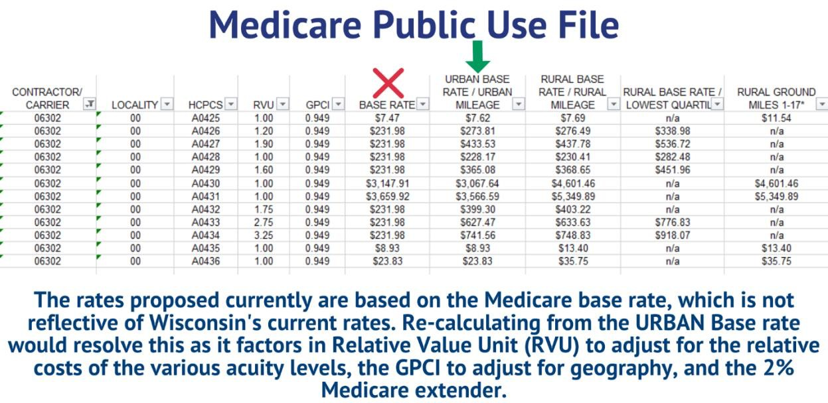

ACTION STEP

We recommend re-calculating the fee adjustments based on the urban base rates shown above below.

